Do Housework 二年 班 號姓名 家長簽名

請小朋友認識下列家事，會聽會說能讀，再將這張學習單帶來學校，並帶彩色鉛筆或彩虹筆來，作為下次活動評量用(參考出處：Household Chores Vocabulary https://www.youtube.com/watch?v=EmHYcOh6uIw )
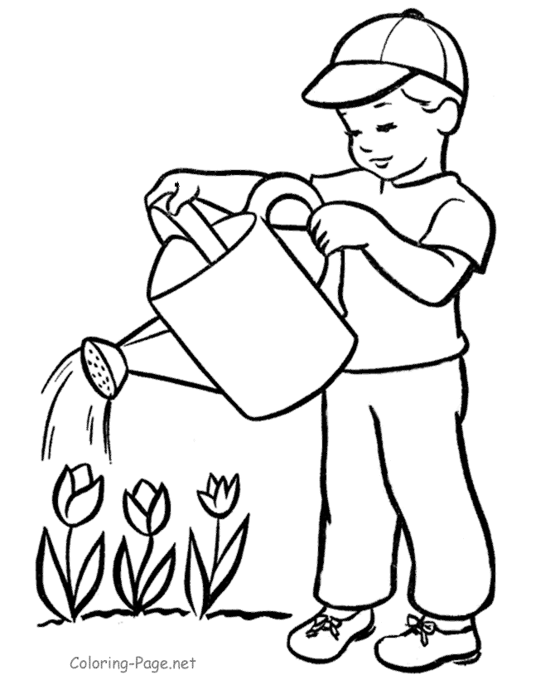  Water the plants. | 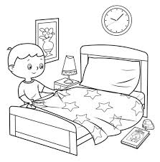  Make the bed. | 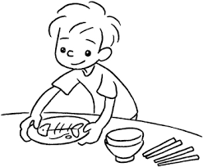  Set the table.
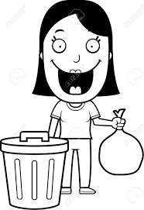  Take out the trash. | 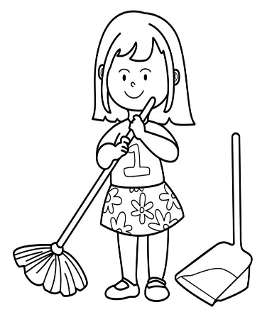  Sweep the floor. | 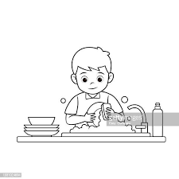  Wash the dishes.
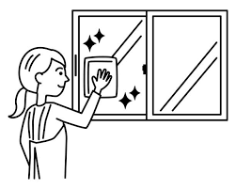  Wash the windows. | 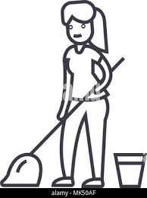  Mop the floor. | 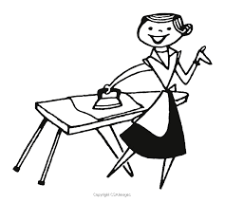  Iron the clothes.
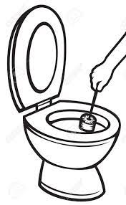  Clean the toilet. | 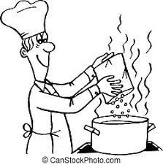  Cook the meals. | 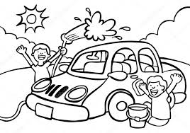  Wash the car.

